***PRACTICAL ASSIGNMENT***

***CLASS : BCA (AIML)B***

***NAME = KRISH REXWAL***

***GROUP 1***

***Q 1= Create a simple html tag using basic tags?***

***<HTML>***

***<HEAD>***

***<TITLE> HELLO WORLD </TITLE>***

***</HEAD>***

***<body>***

***<H1> Your Name </h1>***

***</Body>***

***</html>***



***Q2- Create a webpage that displays your name to the screen?***

***<HTML>***

***<HEAD>***

***<TITLE> HELLO WORLD </TITLE>***

***</HEAD>***

***<body>***

***<H1> KRISH REXWAL </h1>***

***</body>***

***</html>***

***=Output***

***Q3- Create a web page and show the output from 1 to 10***

***<HTML>***

***<HEAD>***

***<TITLE> HELLO WORLD </TITLE>***

***</HEAD>***

***<body>***

***1<br> 2<br> 3<br> 4<br> 5<br> 6<br> 7<br> 8<br> 9<br> 10<br>***

***</body>***

***</html>***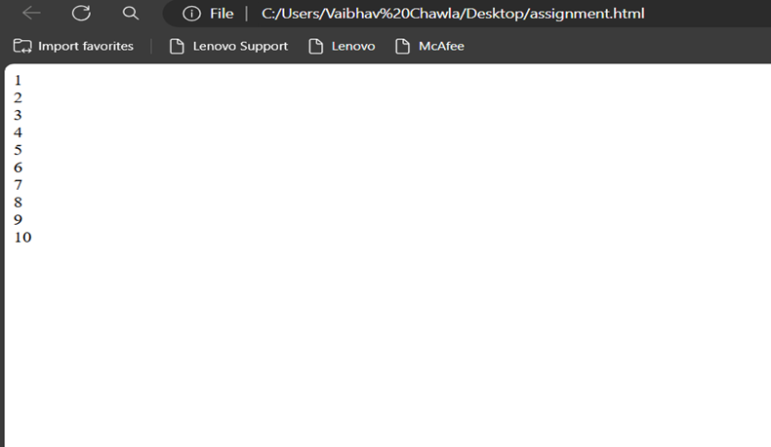

***Q4- Create a webpage and show the output from 1 to 10 in seprate lines , each number being in different color?***

***<HTML>***

***<HEAD>***

***<TITLE> HELLO WORLD </TITLE>***

***</HEAD>***

***<body>***

***<font color="red"> 1 </font><br>***

***<font color="blue"> 2 </font><br>***

***<font color="green"> 3 </font><br>***

***<font color="black"> 4 </font><br>***

***<font color="brown"> 5 </font><br>***

***<font color="pink"> 6 </font><br>***

***<font color="orange"> 7 </font><br>***

***<font color="purple"> 8 </font><br>***

***<font color="grey"> 9 </font><br>***

***<font color="yellow"> 10 </font><br>***

***</body>***

***</html>***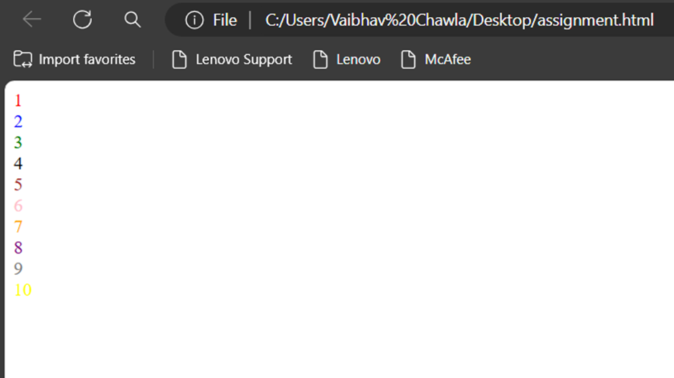

***Q5- how to make a picture as a background on my web pages?***

***<HTML>***

***<HEAD>***

***<TITLE> HELLO WORLD </TITLE>***

***</HEAD>***

***<body>***

***<body background="ai.jpeg">***

***</body>***

***</html>***

**Q6=Create a web page to print a paragraph with 4-5 sentences, each sentences shall have a different font?**

**<html>**

**<head>**

**<title> BCA IB </title>**

**</head>**

**<body>**

**<h1>Krish Rexwal </h1>**

**<P>**

**<B>My name is Krish Rexwal .</B><br>**

**<I>I am Currently studing in manav rachna international institute of research and science. It is situated in**

**Badkhal, Faridabad. </I>**

**<br> <U> My course that i am pursuing right now is BCA(AI/ML) </U>.**

**<br><B> My Hobbies are playing games and watching movies and sometimes i go to play**

**Football with My friends.</B><br>**

**</p>**

**</body>**

**</html>**

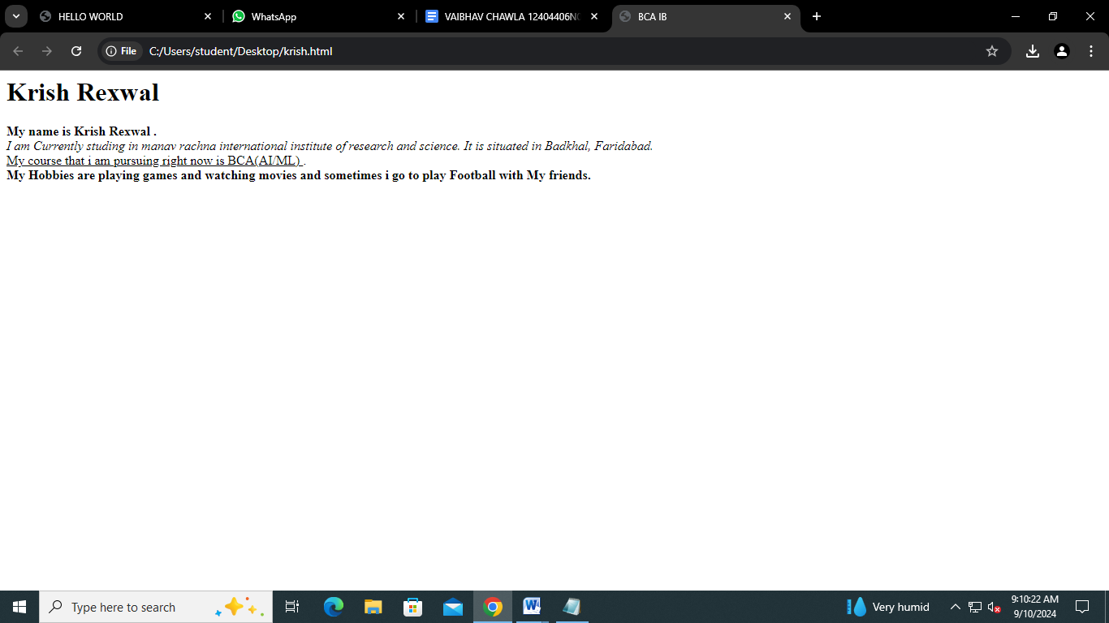

**Q7=write HTML code to print a paragraph that is described of a book, it shall include the title should be underlined and all adjectives shall be bold and italics?**

**<HTML>**

**<HEAD>**

**<TITLE>BOOK </title>**

**</head>**

**<Body>**

**<H1><u><b> Title Of The Book: Harry potter</b></u></H1>**

**<p><i> Author Name: J.K Rowling <br></i>**

**<i>Harry Potter is a series of novels by British author J. K. Rowling. The novels follow Harry Potter,**

**an 11-year-old boy who discovers he is the son of famous wizards and will attend Hogwarts School of Witchcraft and Wizardry.**

**Harry learns of an entire society of wizards and witches. He befriends several Hogwarts students and teachers along his journey.**

**Each novel chronicles one year in Harry's life and**

**his adventures discovering the events that led to his parents' deaths at the hands of Lord Voldermort, a dark wizard believed long dead.</i></P>**

**</p>**

**</body>**

**</html>**

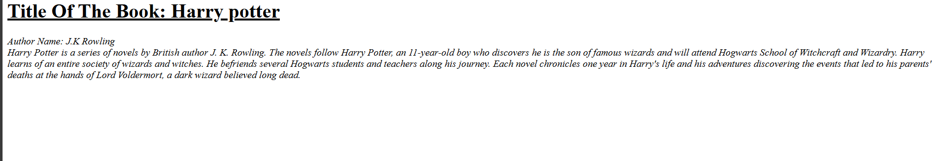

**Q8: Write HTML code to print your name using heading tag, every letter shall be of different heading size?**

**<HTML>**

**<HEAD>**

**<Title> Krish </Title>**

**</HEAD>**

**<BODY>**

**<H1> A</h1>**

**<H2> B</h2>**

**<H3> C</h3>**

**<H4> D</h4><br>**

**<H5> E</h5>**

**<H6> F</h6>**

**<H1> G</h1>**

**<H2> H</h2>**

**</body>**

**</html>**

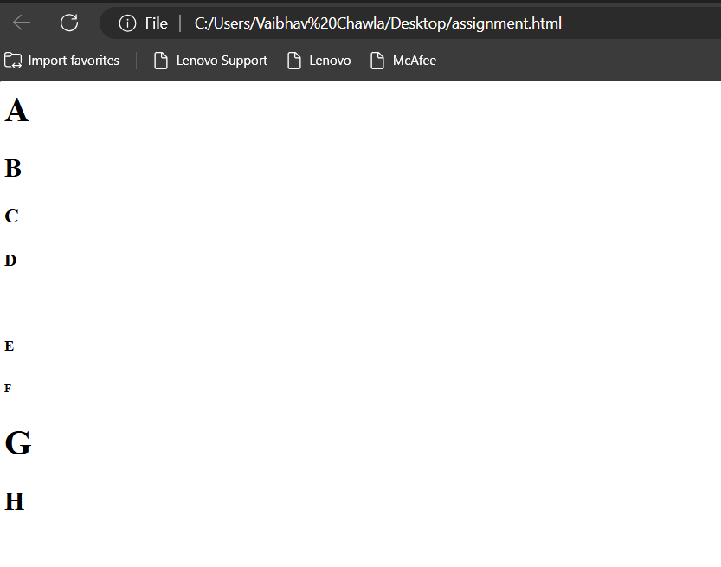

**Q9:Write Html code to print the sequence of number 1-20. each no shall be in different line with number 2 next to it as subscript, an equal sign and the result?**

**<html>**

**<head>**

**<title>Number Sequence</title>**

**</head>**

**<body>**

**<p>1<sub>2</sub> = 1</p>**

**<p>2<sub>2</sub> = 4</p>**

**<p>3<sub>2</sub> = 9</p> <p>4<sub>2</sub> = 16</p> <p>5<sub>2</sub> = 25</p> <p>6<sub>2</sub> = 36</p> <p>7<sub>2</sub> = 49</p> <p>8<sub>2</sub> = 64</p> <p>9<sub>2</sub> = 81</p> <p>10<sub>2</sub> = 100</p> <p>11<sub>2</sub> = 121</p> <p>12<sub>2</sub> = 144</p> <p>13<sub>2</sub> = 169</p> <p>14<sub>2</sub> = 196</p> <p>15<sub>2</sub> = 225</p> <p>16<sub>2</sub> = 256</p> <p>17<sub>2</sub> = 289</p> <p>18<sub>2</sub> = 324</p> <p>19<sub>2</sub> = 361</p> <p>20<sub>2</sub> = 400</p> </body>**

**</html>**

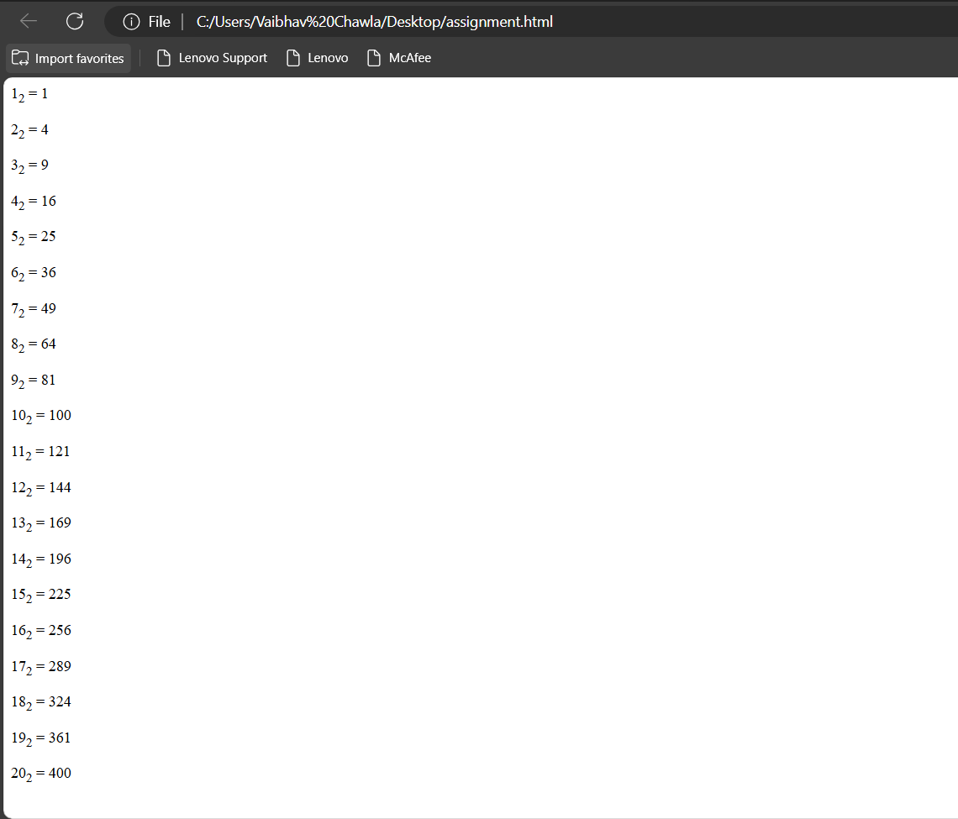

**Q 10 : Write HTML code to display an image with border of size with width 200, height 200 pixels, leaving Hspace and Vspace of your choice with image hanging in the right side on the screen.**

**<html>**

**<body>**

**<h1>The img width attribute</h1>**

**<img src="img_girl.jpg" alt="Girl in a jacket" width="200" height="200">**

**</body>**

**</html>**

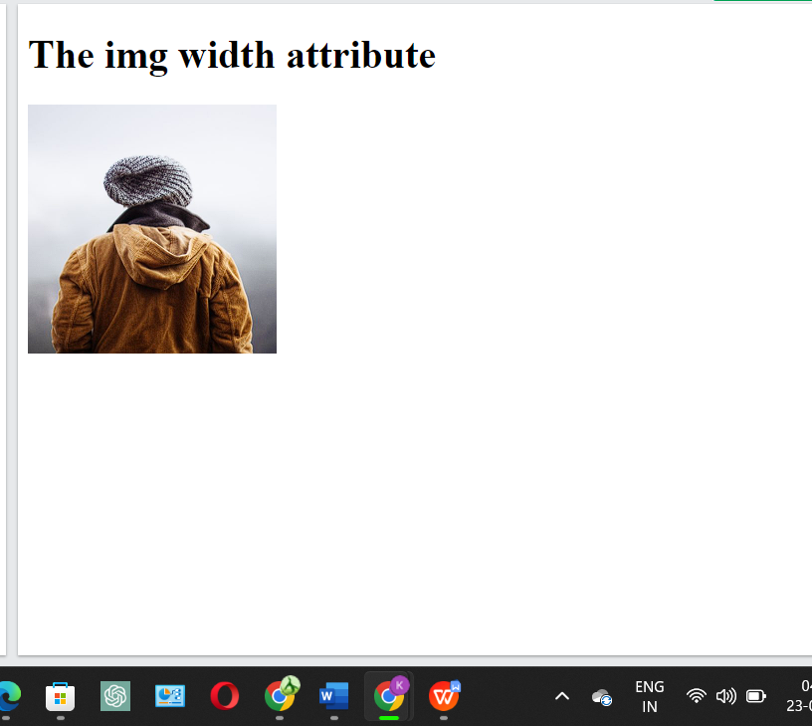

**Q11:Write HTML code to create a web page with heading. The heading shall be displayed at the top-center of the page and the image shall be at the centre, just below the heading.**

**<html>**

**<body>**

**<h1 align="center"> Heading1</h1>**

**<head>**

**<meta name="viewport" content="width=device-width, initial-scale=1">**

**<style>**

**img {**

**display: block;**

**margin-left: auto;**

**margin-right: auto;**

**}**

**</style>**

**</head>**

**<img src="pic_trulli.jpg" alt="Trulli" width="500" height="333">**

**</body>**

**</html>**

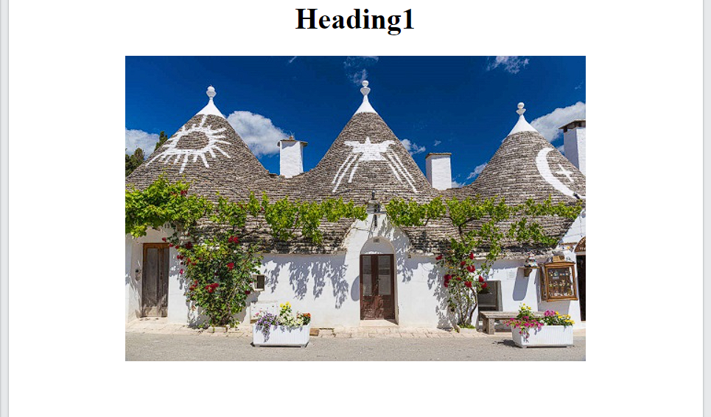

|  |  |
| --- | --- |
| **Q12** | **Write multimedia tags in html ?** |

**VIDEO**

**<html>**

**<body>**

**<video width="320" height="240" controls>**

**<source src="movie.mp4" type="video/mp4">**

**<source src="movie.ogg" type="video/ogg">**

**Your browser does not support the video tag.**

**</video>**

**</body>**

**</html>**

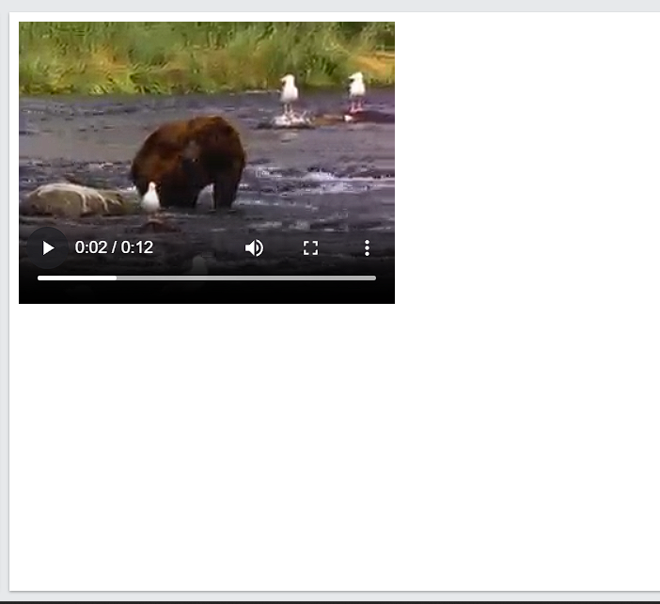

**AUDIO**

**<html>**

**<body>**

**<audio controls autoplay>**

**<source src="horse.ogg" type="audio/ogg">**

**<source src="horse.mp3" type="audio/mpeg">**

**Your browser does not support the audio element.**

**</audio>**

**</body>**

**</html>**

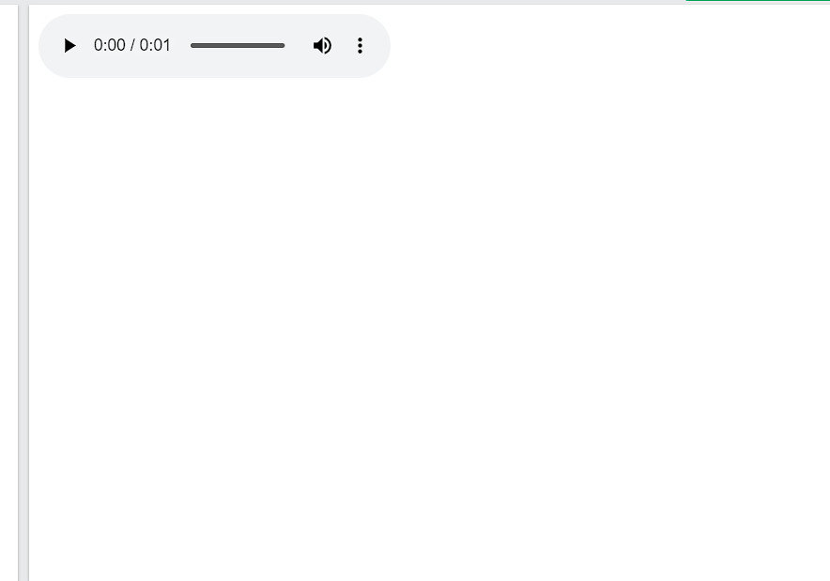

**PLUG INS**

**<html>**

**<body>**

**<object width="100%" height="500px" data="snippet.html"></object>**

**</body>**

**</html>**

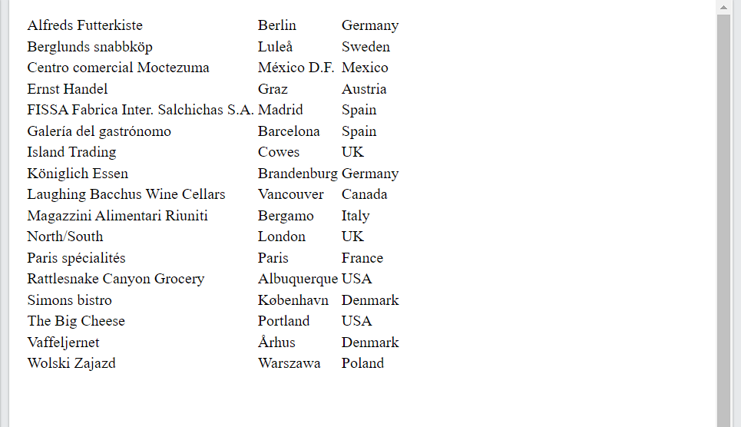

**YOUTUBE VIDEO**

**<html>**

**<body>**

**<object width="100%" height="500px" data="snippet.html"></object>**

**</body>**

**</html>**

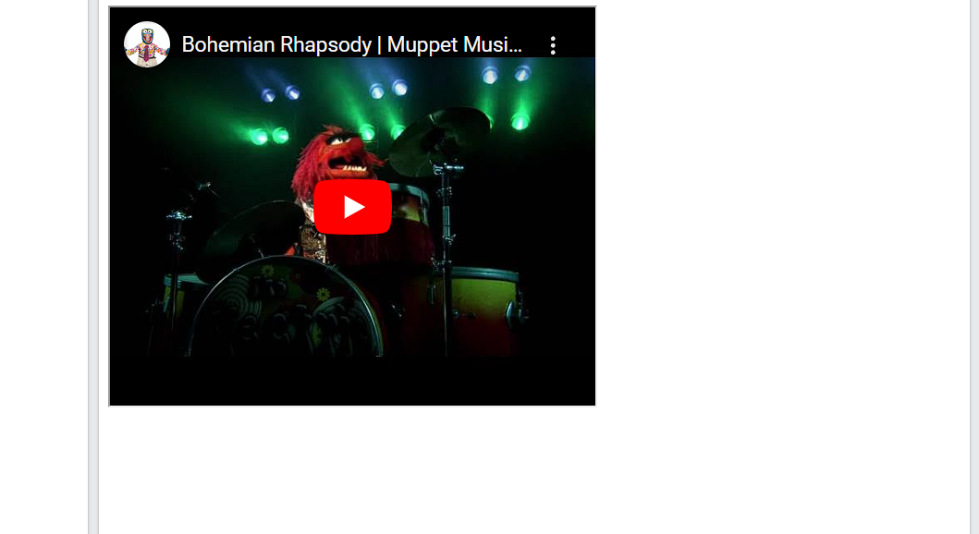

**Q13 Create a Table using Rowspan and Colspan taking example of student Record.**

**COLSPAN**

**<html>**

**<head>**

**<style>**

**table, th, td {**

**border: 1px solid black;**

**border-collapse: collapse;**

**}**

**</style>**

**</head>**

**<body>**

**<h2>Cell that spans two columns</h2>**

**<p>To make a cell span more than one column, use the colspan attribute.</p>**

**<table style="width:100%">**

**<tr>**

**<th colspan="2">Name</th>**

**<th>Age</th>**

**</tr>**

**<tr>**

**<td>Jill</td>**

**<td>Smith</td>**

**<td>43</td>**

**</tr>**

**<tr>**

**<td>Eve</td>**

**<td>Jackson</td>**

**<td>57</td>**

**</tr>**

**</table>**

**</body>**

**</html>**

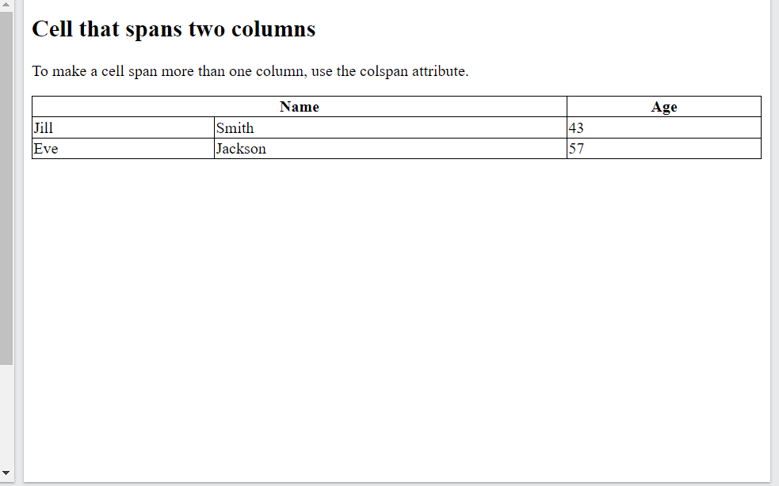

**ROWSPAN**

**<html>**

**<head>**

**<style>**

**table, th, td {**

**border: 1px solid black;**

**border-collapse: collapse;**

**}**

**</style>**

**</head>**

**<body>**

**<h2>Cell that spans two rows</h2>**

**<p>To make a cell span more than one row, use the rowspan attribute.</p>**

**<table style="width:100%">**

**<tr>**

**<th>Name</th>**

**<td>Jill</td>**

**</tr>**

**<tr>**

**<th rowspan="2">Phone</th>**

**<td>555-1234</td>**

**</tr>**

**<tr>**

**<td>555-8745</td>**

**</tr>**

**</table>**

**</body>**

**</html**

|  |  |
| --- | --- |
| **14.** | **Write HTML code using table tag <table> and cellpadding and cell spacing as its attributes.** |

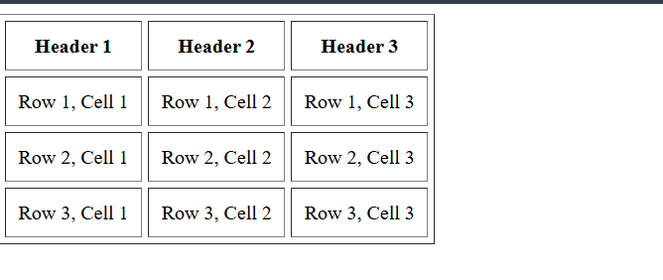

**<html lang="en">**

**<head>**

**<meta charset="UTF-8">**

**<meta name="viewport" content="width=device-width, initial-scale=1.0">**

**<title>Table Example</title>**

**</head>**

**<body>**

**<table cellpadding="10" cellspacing="5" border="1">**

**<tr>**

**<th>Header 1</th>**

**<th>Header 2</th>**

**<th>Header 3</th>**

**</tr>**

**<tr>**

**<td>Row 1, Cell 1</td>**

**<td>Row 1, Cell 2</td>**

**<td>Row 1, Cell 3</td>**

**</tr>**

**<tr>**

**<td>Row 2, Cell 1</td>**

**<td>Row 2, Cell 2</td>**

**<td>Row 2, Cell 3</td>**

**</tr>**

**<tr>**

**<td>Row 3, Cell 1</td>**

**<td>Row 3, Cell 2</td>**

**<td>Row 3, Cell 3</td>**

**</tr>**

**</table>**

**</body>**

**</html>**

|  |  |
| --- | --- |
| **15.** | **Create unordered, ordered and definition Lists taking example of your subjects in MCA IST, IInd and IIIrd Semester.** |

**Unordered**

**<h2>Subjects in MCA IST - 2nd Semester</h2>**

**<ul>**

**<li>Data Structures</li>**

**<li>Database Management Systems</li>**

**<li>Object-Oriented Programming</li>**

**<li>Software Engineering</li>**

**</ul>**

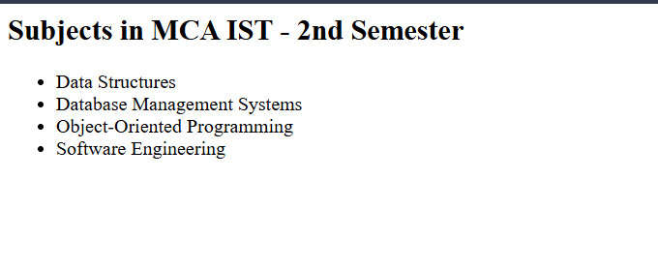

**Ordered**

**<h2>Subjects in MCA IST - 3rd Semester</h2>**

**<ol>**

**<li>Advanced Java Programming</li>**

**<li>Web Technologies</li>**

**<li>Computer Networks</li>**

**<li>Mobile Application Development</li>**

**</ol>**

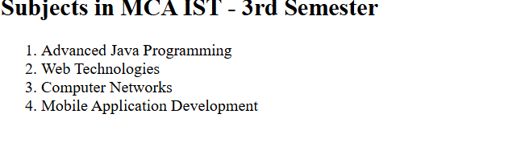

**Definition**

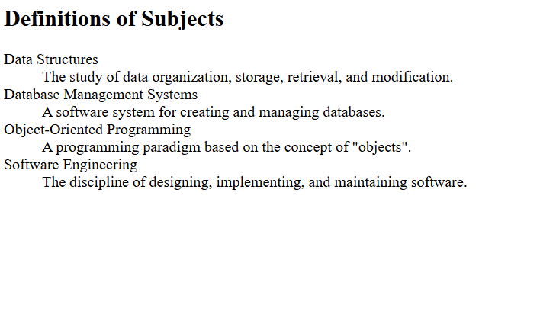

**<h2>Definitions of Subjects</h2>**

**<dl>**

**<dt>Data Structures</dt>**

**<dd>The study of data organization, storage, retrieval, and modification.</dd>**

**<dt>Database Management Systems</dt>**

**<dd>A software system for creating and managing databases.</dd>**

**<dt>Object-Oriented Programming</dt>**

**<dd>A programming paradigm based on the concept of "objects".</dd>**

**<dt>Software Engineering</dt>**

**<dd>The discipline of designing, implementing, and maintaining software.</dd>**

**</dl>**

**Q17. Write HTML code to design a form in HTML using controls and buttons such as Textbox, Text area, password, submit button, browse button, drop-down menu**

**<html lang="en">**

**<head>**

**<meta charset="UTF-8">**

**<meta name="viewport" content="width=device-width, initial-scale=1.0">**

**<title>Sample Form</title>**

**</head>**

**<body>**

**<h2>Sample Form</h2>**

**<form action="/submit" method="post">**

**<!-- Textbox for Name -->**

**<label for="name">Name:</label>**

**<input type="text" id="name" name="name" required><br><br>**

**<!-- Text Area for Address -->**

**<label for="address">Address:</label><br>**

**<textarea id="address" name="address" rows="4" cols="50"></textarea><br><br>**

**<!-- Password Field -->**

**<label for="password">Password:</label>**

**<input type="password" id="password" name="password" required><br><br>**

**<!-- File Upload (Browse) Button -->**

**<label for="file">Upload Document:</label>**

**<input type="file" id="file" name="file"><br><br>**

**<!-- Dropdown Menu -->**

**<label for="country">Country:</label>**

**<select id="country" name="country">**

**<option value="usa">USA</option>**

**<option value="uk">UK</option>**

**<option value="canada">Canada</option>**

**<option value="australia">Australia</option>**

**</select><br><br>**

**<!-- Submit Button -->**

**<input type="submit" value="Submit">**

**</form>**

**</body>**

**</html>**

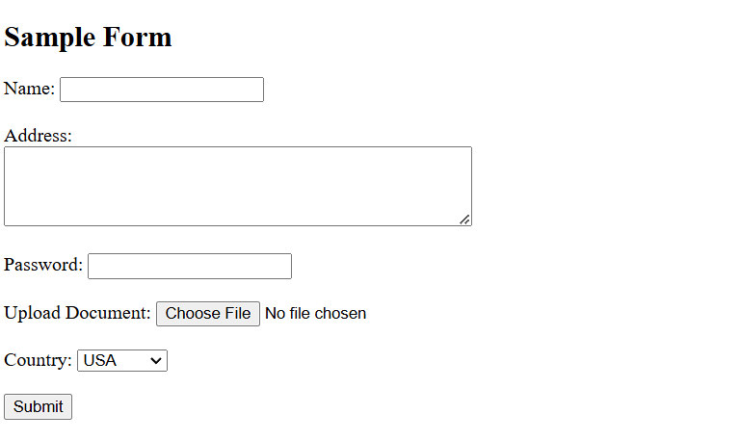

18. Write HTML code to design a Registration Form in HTML.

<!DOCTYPE html>

<html lang="en">

<head>

<meta charset="UTF-8">

<meta name="viewport" content="width=device-width, initial-scale=1.0">

<title>Sample Form</title>

</head>

<body>

<h2>Sample Form</h2>

<form action="/submit" method="post">

<!-- Textbox for Name -->

<label for="name">Name:</label>

<input type="text" id="name" name="name" required><br><br>

<!-- Text Area for Address -->

<label for="address">Address:</label><br>

<textarea id="address" name="address" rows="4" cols="50"></textarea><br><br>

<!-- Password Field -->

<label for="password">Password:</label>

<input type="password" id="password" name="password" required><br><br>

<!-- File Upload (Browse) Button -->

<label for="file">Upload Document:</label>

<input type="file" id="file" name="file"><br><br>

<!-- Dropdown Menu -->

<label for="country">Country:</label>

<select id="country" name="country">

<option value="usa">USA</option>

<option value="uk">UK</option>

<option value="canada">Canada</option>

<option value="australia">Australia</option>

</select><br><br>

<!-- Submit Button -->

<input type="submit" value="Submit">

</form>

</body>

</html>

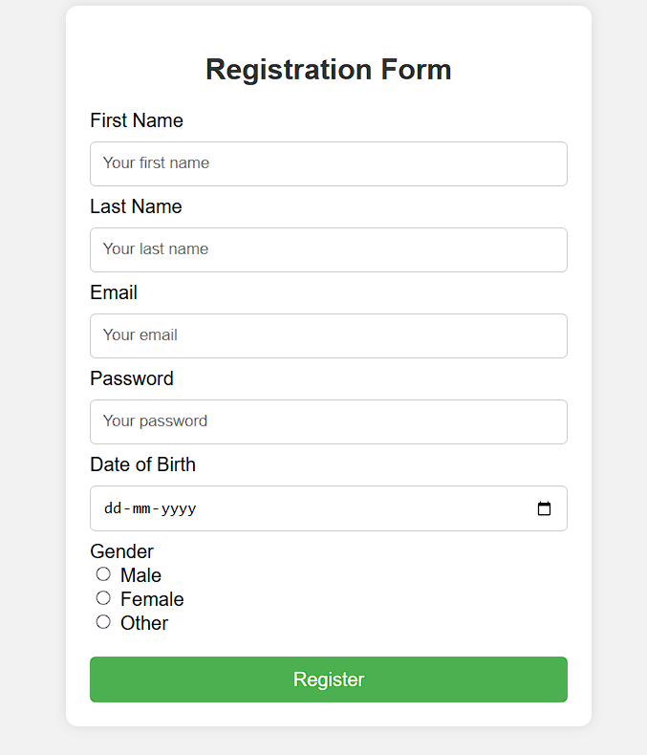

19. Write HTML code to design a student admission Form in HTML.

<!DOCTYPE html>

<html lang="en">

<head>

<meta charset="UTF-8">

<meta name="viewport" content="width=device-width, initial-scale=1.0">

<title>Student Admission Form</title>

</head>

<body>

<h2>Student Admission Form</h2>

<form action="/submit" method="post">

<!-- Personal Information Section -->

<fieldset>

<legend>Personal Information</legend>

<label for="firstName">First Name:</label>

<input type="text" id="firstName" name="firstName" required><br><br>

<label for="lastName">Last Name:</label>

<input type="text" id="lastName" name="lastName" required><br><br>

<label for="dob">Date of Birth:</label>

<input type="date" id="dob" name="dob" required><br><br>

<label for="gender">Gender:</label>

<select id="gender" name="gender" required>

<option value="">Select</option>

<option value="male">Male</option>

<option value="female">Female</option>

<option value="other">Other</option>

</select><br><br>

<label for="address">Address:</label><br>

<textarea id="address" name="address" rows="3" cols="40" required></textarea><br><br>

</fieldset>

<!-- Contact Information Section -->

<fieldset>

<legend>Contact Information</legend>

<label for="phone">Phone Number:</label>

<input type="tel" id="phone" name="phone" required><br><br>

<label for="email">Email:</label>

<input type="email" id="email" name="email" required><br><br>

</fieldset>

<!-- Academic Information Section -->

<fieldset>

<legend>Academic Information</legend>

<label for="prevSchool">Previous School:</label>

<input type="text" id="prevSchool" name="prevSchool" required><br><br>

<label for="grade">Grade Applying For:</label>

<select id="grade" name="grade" required>

<option value="">Select</option>

<option value="1">Grade 1</option>

<option value="2">Grade 2</option>

<option value="3">Grade 3</option>

<!-- Add more options as needed -->

</select><br><br>

<label for="fileUpload">Upload Recent Photo:</label>

<input type="file" id="fileUpload" name="fileUpload" required><br><br>

</fieldset>

<!-- Submit Button -->

<input type="submit" value="Submit">

</form>

</body>

</html>

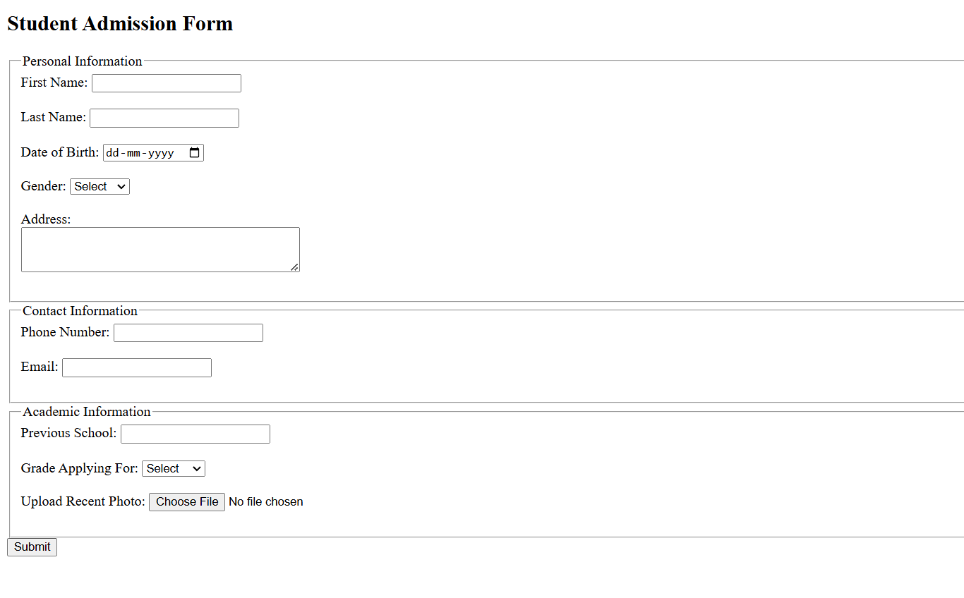

20. Create a proper home page of your own using any components and styles.

**<!DOCTYPE html>**

**<html lang="en">**

**<head>**

**<meta charset="UTF-8">**

**<meta name="viewport" content="width=device-width, initial-scale=1.0">**

**<title>My Homepage</title>**

**<style>**

**/* Basic reset */**

**\* {**

**margin: 0;**

**padding: 0;**

**box-sizing: border-box;**

**}**

**/* Body styling */**

**body {**

**font-family: Arial, sans-serif;**

**color: #333;**

**background-color: #f4f4f9;**

**line-height: 1.6;**

**display: flex;**

**flex-direction: column;**

**align-items: center;**

**padding-top: 50px;**

**}**

**/* Header styling */**

**header {**

**width: 100%;**

**text-align: center;**

**padding: 20px;**

**background-color: #282c34;**

**color: #fff;**

**}**

**header h1 {**

**font-size: 2.5em;**

**margin-bottom: 10px;**

**}**

**/* Navigation styling */**

**nav {**

**margin: 20px 0;**

**}**

**nav a {**

**text-decoration: none;**

**color: #282c34;**

**background-color: #61dafb;**

**padding: 10px 20px;**

**margin: 0 10px;**

**border-radius: 5px;**

**transition: background-color 0.3s;**

**}**

**nav a:hover {**

**background-color: #21a1f1;**

**}**

**/* Main content styling */**

**.content {**

**max-width: 800px;**

**text-align: center;**

**padding: 20px;**

**background-color: #fff;**

**border-radius: 10px;**

**box-shadow: 0 0 10px rgba(0, 0, 0, 0.1);**

**}**

**.content h2 {**

**margin-bottom: 10px;**

**}**

**.content p {**

**margin-bottom: 20px;**

**font-size: 1.1em;**

**}**

**/* Footer styling */**

**footer {**

**margin-top: 40px;**

**padding: 10px;**

**color: #555;**

**font-size: 0.9em;**

**text-align: center;**

**width: 100%;**

**}**

**</style>**

**</head>**

**<body>**

**<!-- Header Section -->**

**<header>**

**<h1>Welcome to My Homepage</h1>**

**<p>Your one-stop destination to know more about me</p>**

**</header>**

**<!-- Navigation Links -->**

**<nav>**

**<a href="#about">About Me</a>**

**<a href="#portfolio">Portfolio</a>**

**<a href="#contact">Contact</a>**

**</nav>**

**<!-- Main Content Section -->**

**<div class="content" id="about">**

**<h2>About Me</h2>**

**<p>Hello! I'm a web enthusiast with a passion for coding and design. I love creating beautiful and functional websites and am always eager to learn new technologies.</p>**

**<p>With a background in web development, I have experience in HTML, CSS, JavaScript, and am constantly working on new projects to expand my skills.</p>**

**</div>**

**<div class="content" id="portfolio">**

**<h2>Portfolio</h2>**

**<p>Here are some of my recent projects. I enjoy working on both front-end and back-end development to create a seamless user experience.</p>**

**<!-- Add your project details or images here -->**

**</div>**

**<div class="content" id="contact">**

**<h2>Contact</h2>**

**<p>If you'd like to get in touch, feel free to drop me a message. I’d love to hear from you!</p>**

**<!-- Contact details or form can be added here -->**

**</div>**

**<!-- Footer Section -->**

**<footer>**

**&copy; 2023 My Homepage. All rights reserved.**

**</footer>**

**</body>**

**</html>**

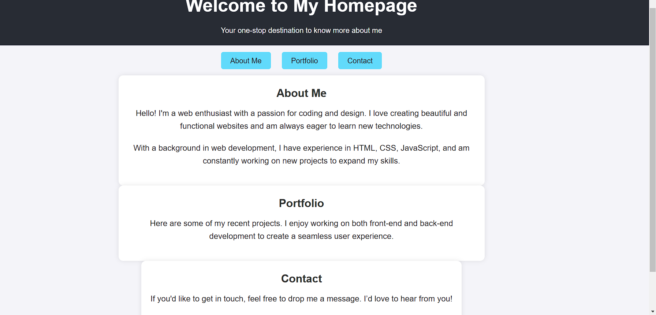

|  |  |
| --- | --- |
| **21.** | **Write HTML code for including Local hyperlinking in a web page.** |

**<!DOCTYPE html>**

**<html lang="en">**

**<head>**

**<meta charset="UTF-8">**

**<meta name="viewport" content="width=device-width, initial-scale=1.0">**

**<title>Local Hyperlinking Example</title>**

**</head>**

**<body>**

**<h1>Local Hyperlinking Example</h1>**

**<!-- Navigation Links -->**

**<ul>**

**<li><a href="#section1">Go to Section 1</a></li>**

**<li><a href="#section2">Go to Section 2</a></li>**

**<li><a href="#section3">Go to Section 3</a></li>**

**</ul>**

**<!-- Content Sections -->**

**<h2 id="section1">Section 1</h2>**

**<p>This is the content of Section 1. It contains some sample text for demonstration purposes.</p>**

**<h2 id="section2">Section 2</h2>**

**<p>This is the content of Section 2. This section also has some sample text for hyperlinking demonstration.</p>**

**<h2 id="section3">Section 3</h2>**

**<p>This is the content of Section 3. You can navigate back to the top or to other sections using local hyperlinks.</p>**

**<!-- Link to g**

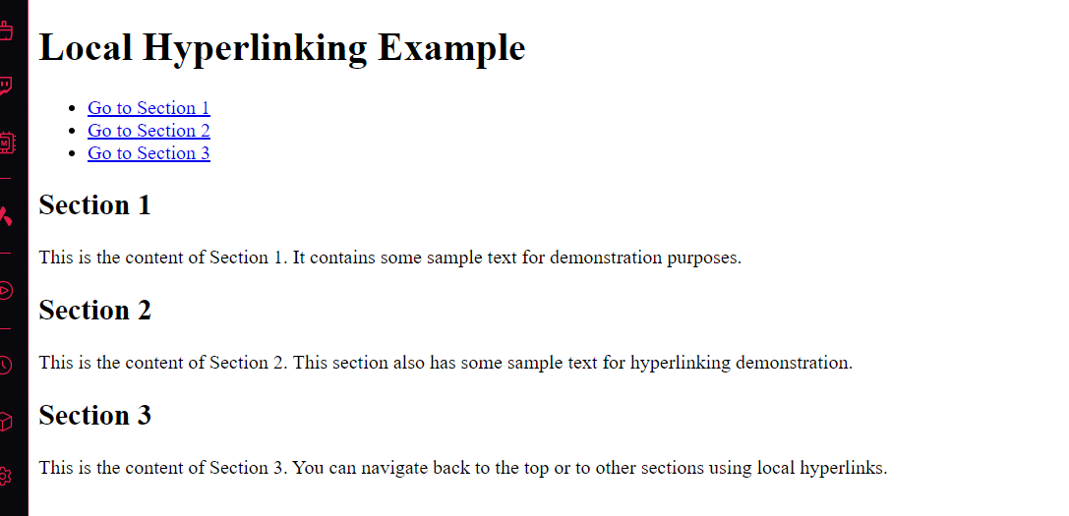

|  |  |
| --- | --- |
| **22.** | **Write HTML code for including Inter hyperlinking in a web page.** |

**<!DOCTYPE html>**

**<html lang="en">**

**<head>**

**<meta charset="UTF-8">**

**<meta name="viewport" content="width=device-width, initial-scale=1.0">**

**<title>Inter Hyperlinking Example</title>**

**</head>**

**<body>**

**<h1>Welcome to the Main Page</h1>**

**<!-- Inter-page Hyperlinks -->**

**<p>Navigate to different pages:</p>**

**<ul>**

**<li><a href="about.html">Go to About Page</a></li>**

**<li><a href="services.html">Go to Services Page</a></li>**

**<li><a href="contact.html">Go to Contact Page</a></li>**

**</ul>**

**<p>Click on the links above to visit different sections of the website.</p>**

**</body>**

**</html>**

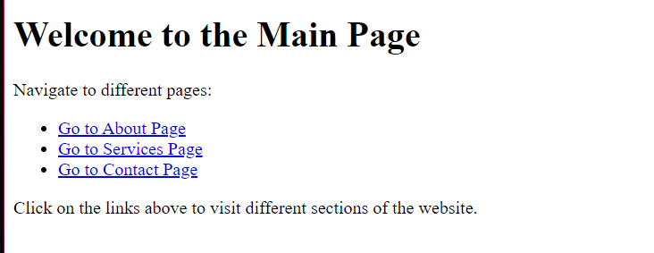

|  |  |
| --- | --- |
| **23.** | **Write HTML code for including External hyperlinking in a web page.** |

**<!DOCTYPE html>**

**<html lang="en">**

**<head>**

**<meta charset="UTF-8">**

**<meta name="viewport" content="width=device-width, initial-scale=1.0">**

**<title>External Hyperlinking Example</title>**

**</head>**

**<body>**

**<h1>External Hyperlinking Example</h1>**

**<!-- External Hyperlinks -->**

**<p>Check out these useful external links:</p>**

**<ul>**

**<li><a href="https://www.wikipedia.org" target="_blank">Visit Wikipedia</a></li>**

**<li><a href="https://www.google.com" target="_blank">Go to Google</a></li>**

**<li><a href="https://www.github.com" target="_blank">Explore GitHub</a></li>**

**</ul>**

**<p>Clicking on these links will take you to the respective websites in a new tab.</p>**

**</body>**

**</html>**

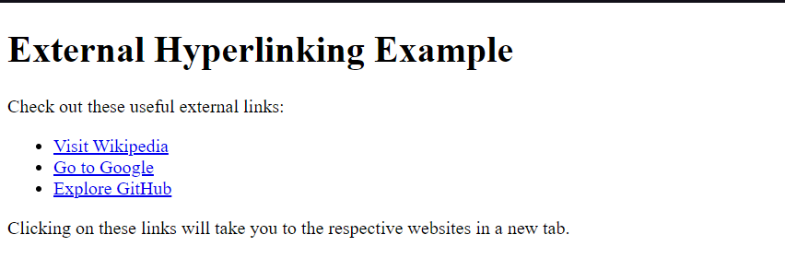

|  |  |
| --- | --- |
| **24.** | **Write code to show External CSS with HTML code** |

**<!DOCTYPE html>**

**<html lang="en">**

**<head>**

**<meta charset="UTF-8">**

**<meta name="viewport" content="width=device-width, initial-scale=1.0">**

**<title>External CSS Example</title>**

**<!-- Link to the external CSS file -->**

**<link rel="stylesheet" href="styles.css">**

**</head>**

**<body>**

**<h1>Welcome to My Web Page</h1>**

**<p>This is an example of an HTML page styled with an external CSS file. The CSS defines the layout, colors, and font styles.</p>**

**<p>Visit <a href="https://www.example.com" target="_blank">Example.com</a> for more information.</p>**

**</body>**

**</html>**



|  |  |
| --- | --- |
| **25.** | **Write code to show Internal CSS with HTML code.** |

**<!DOCTYPE html>**

**<html lang="en">**

**<head>**

**<meta charset="UTF-8">**

**<meta http-equiv="X-UA-Compatible" content="IE=edge">**

**<meta name="viewport" content="width=device-width, initial-scale=1.0">**

**<title>Internal CSS Example</title>**

**<style>**

**/* Internal CSS */**

**body {**

**font-family: Arial, sans-serif;**

**background-color: #f0f8ff;**

**margin: 20px;**

**}**

**h1 {**

**color: #3333cc;**

**text-align: center;**

**}**

**p {**

**color: #555;**

**font-size: 16px;**

**line-height: 1.5;**

**}**

**.highlight {**

**background-color: #ffffcc;**

**padding: 10px;**

**border-radius: 5px;**

**}**

**</style>**

**</head>**

**<body>**

**<h1>Welcome to Internal CSS Demo</h1>**

**<p>This is an example of how to use internal CSS in an HTML document.</p>**

**<p class="highlight">This paragraph is styled with a class to show a highlighted background.</p>**

**</body>**

**</html>**

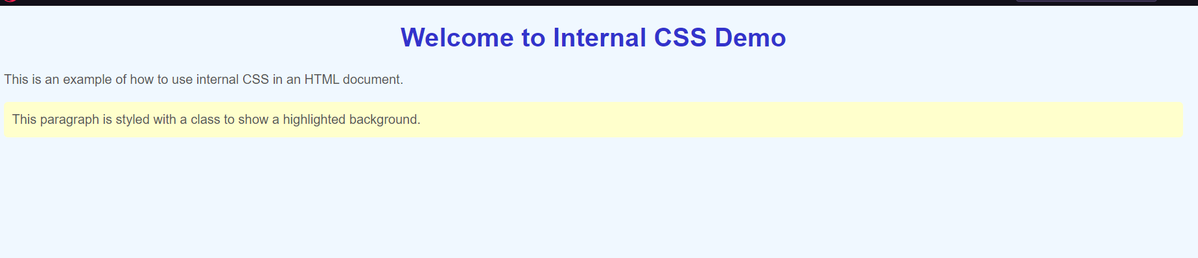

|  |  |
| --- | --- |
| **26.** | **Write code to show Inline CSS with HTML code.** |

**<!DOCTYPE html>**

**<html lang="en">**

**<head>**

**<meta charset="UTF-8">**

**<meta http-equiv="X-UA-Compatible" content="IE=edge">**

**<meta name="viewport" content="width=device-width, initial-scale=1.0">**

**<title>Inline CSS Example</title>**

**</head>**

**<body>**

**<h1 style="color: #336699; text-align: center;">Welcome to Inline CSS Demo</h1>**

**<p style="color: #555; font-size: 18px; line-height: 1.6;">**

**This paragraph is styled with <strong>inline CSS</strong> to show how it works directly within an element.**

**</p>**

**<**



